|  |
| --- |
| Prescribed Fire Plan |

# Element 1: Signature Page

|  |  |
| --- | --- |
| **Administrative Unit(s):** | **BIA Crow Creek Agency** |
| **Project Name:** | **Crow Creek** |
| **Burn Unit Name:** | **Red Bull** |
| **Complexity Rating:** | **Moderate** |
| **Minimum RXB Requirement:** |  |

|  | **Name and Qualification or Position** | **Date** |
| --- | --- | --- |
| **Prepared By:** |  |  |
| **Technical Reviewer:** |  |  |
| **Concurrence:** |  |  |
| **Concurrence:** |  |  |
|  |  |  |
| **Approved By:** |  |  |
| **Agency Administrator** |

# Element 2, Part 1: Agency Administrator GO/NO-GO Pre-Ignition Approval Checklist

**Instructions:** The Agency Administrator’s GO/NO-GO Pre-Ignition Approval is the intermediate planning review process (i.e., between the Prescribed Fire Complexity Rating System Guide and Go/No-Go Checklist) that should be completed before a prescribed fire can be implemented. The Agency Administrator’s Go/No-Go Pre-Ignition Approval evaluates whether compliance requirements, Prescribed Fire Plan elements, and internal and external notifications have been or will be completed and expresses the Agency Administrator’s intent to implement the Prescribed Fire Plan. If ignition of the prescribed fire is not initiated prior to the expiration date determined by the Agency Administrator, a new approval is required.

|  |  |  |
| --- | --- | --- |
| Yes | No | Key Element Questions |
|  |  | Is the Prescribed Fire Plan up to date?  *Hints: amendments, seasonality.* |
|  |  | Will all compliance requirements be completed?  *Hints: cultural, threatened and endangered species, smoke management, NEPA.* |
|  |  | Is risk management in place and the residual risk acceptable?  *Hints: Prescribed Fire Complexity Rating Guide completed with rational and mitigation measures identified and documented?* |
|  |  | Will all elements of the Prescribed Fire Plan be met?  *Hints: preparation work, mitigation, weather, organization, prescription, contingency resources.* |
|  |  | Will all internal and external notifications and media releases be completed?  *Hints: preparedness level restrictions.* |
|  |  | Will key agency staff be fully briefed and understand prescribed fire implementation? |
|  |  | Are there any other extenuating circumstances that would preclude the successful implementation of the plan? |
|  |  | Have you determined if and when you are to be notified that contingency actions are being taken? Will this be communicated to the Burn Boss? |
|  |  | Other: |

Recommended by: _______________________________________ Date: ______________  
 FMO/Prescribed Fire Burn Boss

Approved by: ___________________________________________ Date: _______________  
 Agency Administrator

Approval expires (date): ___________________________________

# Element 2, Part 2: Prescribed Fire GO/NO-GO Checklist

|  |  |  |
| --- | --- | --- |
| Item | Yes | No |
| **A**. Has the burn unit experienced unusual drought conditions or does it contain above-normal fuel loadings which were not considered in the prescription development?   * If **No**, proceed with checklist below. * If **Yes**, go to item **B**. |  |  |
| **B**. Has the prescribed fire plan been reviewed and an amendment and technical review been completed, or has it been determined that no amendment is necessary?   * If **Yes** to any, proceed with checklist below. * If **No**, **STOP**. |  |  |

|  |  |  |
| --- | --- | --- |
| Yes | No | Questions |
|  |  | Have ALL pre-burn prescription parameters been met? |
|  |  | Have ALL smoke management specifications been met? |
|  |  | Has ALL required current and projected fire weather forecasts been obtained and are they favorable? |
|  |  | Are ALL planned operations personnel and equipment onsite, available, and operational? |
|  |  | Has the availability of ALL contingency resources been checked and are they available? |
|  |  | Have ALL personnel been briefed on the project objectives, their assignment, safety hazards, escape routes, and safety zones? |
|  |  | Have all the pre-burn considerations identified in the Prescribed Fire Plan been completed or addressed? |
|  |  | Have ALL the required notifications been made? |
|  |  | Have ALL permits and clearances been obtained? |
|  |  | In your opinion, can the burn be carried out according to the Prescribed Fire Plan, and will it meet the planned objective? |

**If all the questions were answered with “Yes,” proceed with a test fire. Document the current conditions, location, and results.**

____________________________________ _________________________  
Burn Boss Date

# Element 3: Complexity Analysis Summary

|  |  |  |  |
| --- | --- | --- | --- |
| Burn Unit Name: Red Bull | | | |
| Element | Risk | Potential Consequence | Technical Difficulty |
| 1. Potential for escape | **L** | **M** | **L** |
| 2. The number and dependence of activities | **M** | **M** | **M** |
| 3. Offsite values | **M** | **M** | **M** |
| 4. Onsite values | **M** | **M** | **M** |
| 5. Fire behavior | **M** | **M** | **L** |
| 6. Management organization | **M** | **L** | **M** |
| 7. Public and political interest | **M** | **M** | **L** |
| 8. Fire treatment objectives | **L** | **M** | **M** |
| 9. Constraints | **L** | **L** | **L** |
| 10. Safety | **M** | **M** | **M** |
| 11. Ignition procedures/ methods | **M** | **M** | **L** |
| 12. Interagency coordination | **L** | **L** | **L** |
| 13. Project logistics | **M** | **M** | **L** |
| 14. Smoke management | **L** | **L** | **L** |

|  |  |
| --- | --- |
| Complexity Rating Summary | |
| Complexity Factor | Overall Rating |
| Risk | **Moderate** |
| Consequences | **Moderate** |
| Technical Difficulty | **Moderate** |
| Summary Complexity Determination | **Moderate** |
| **Rationale:**  **This burn rates a moderate complexity due to the homes and structures within the burn unit and the fact that slow and deliberate ignition procedures are required using**  **highly mobile holding resources on constructed control lines. Even though this type of ignition is common in Indian Country and considered standard operating procedure for most of our Agency fire personnel, the consequences of failure are great. Care must be taken to complete the burn successfully to ensure public and crew safety. Safety and escaped fire risk have been mitigated by:**  **- Requiring the use of qualified personnel in all positions.**  **- Timing of the burn (both time of year and time of day).**  **- Requiring careful ignition methods to achieve desired fire behavior and adequate buffers**  **before completing the burn by head-firing.**  **- The capability to halt burning virtually at any time during the operation.** | |

# Element 4: Description of the Prescribed Fire Area

|  |  |  |
| --- | --- | --- |
| Element 4: Description of the Prescribed Fire Area | Project Name: Crow Creek | |
| Burn Unit Name: Red Bull | |
| 1. Physical Description | | |
| **Location:** Narrative description of the location of the prescribed fire project, including legal description, Universal Transverse Mercator coordinates and/or latitude/longitude (decimal degrees; NAD83 preferred), county, and state. | | |
| **Buffalo County, South Dakota**  **T107N, R72W, Sect. 23 & 24**  **Latitude: 44.0015, Longitude: -99.2526** | | |
| **Size:** Area, in acres of the project with a breakdown by prescribed fire unit and/or ownership if applicable. | | |
| **Project size: 37 acres**  **Acres to be burned: 28** | | |
| **Topography:** Identify the upper and lower range of elevation, slopes (max, min, and average), and aspect(s) of the prescribed fire project. | | |
| **Elevation: Top: 1465 ft, Bottom: 1375 ft**  **Aspect: South**  **Slope % (Average): 5% - upper (north side) flats, 40% - south third, flat bottom - 50 ft average north of the south project boundary** | | |
| **Project Boundary:** **The project area boundary defines that area where the fire will be ignited and may be allowed to burn.** Describe the physical, natural, and/or human-made boundaries (including multiple units) of the prescribed fire project. This will be done through maps and may include narratives. The entire prescribed fire project must be analyzed under NEPA. | | |
| **The project boundary is 37 acres located north of the Missouri River, approximately .3 miles east of Gingway housing, and approximately .2 miles west of East housing (see attached map). Some portions of the unit are adjacent to resident properties and three structures are within the burn unit, with one being an abandoned, dilapidated house. The unit is bordered by predominantly U.S. Corps of Engineers land to the south, with the Missouri River to the south of that, private property to the east, tribal lands to the northeast, private property (cropland) to the north and northwest, with a 2.5 acre home-site in the northwest corner of the project area and predominately U.S. Corps of Engineers land on the west border of the burn unit. The entire project area is within the boundaries of the Crow Creek Reservation on Tribal lands.** | | |
| 1. Vegetation/Fuels Description | | |
| Onsite Fuels Data | | Adjacent/Surrounding Area Fuels Data |
| **Onsite fuels data: Fuel model 3 (over 75%) and 1, with grass as the primary carrier, and small inclusions of hardwoods, characterized as a fuel**  **model 9. Fuel model 3 best represents fire behavior inside of the burn unit. The burn site is dominated by smooth brome, big bluestem, and other native grasses. Coverage is continuous with only minor breaks.**  **0-1/4 in. 1-hour fuels: ~3 tons/acre**  **Fuel height: 3 ft.**  **Duff depth: ½ in.** | | **Adjacent fuels data: Fuel models 1, 3 and 9, scattered along all the boundaries. On the lower edge are scattered stands of hardwood tree species and narrow wooded draws to the east and west, best described by fuel model 9. Fuel model 3 best represents fire behavior outside of the burn unit.** |
| 1. Description of Unique Features | | |
| **The burn unit has structures within it that will need to be protected prior to burning. A dirt road accesses the structures from the middle of the north side of the unit. A fence line runs in an east west direction thru the middle of the prescribed fire unit. Power poles, wooden fence poles, and old dump sites are areas that will be protected or excluded from the burn. Two archaeology sites are located along the east boundary and north, middle flat that do not require any special protection, other than to make sure that no equipment drives over these sites.**  **Special Considerations: The only smoke receptors of concern are the homes within and adjacent to the burn unit, adjacent communities and disbursed housing along nearby roads. According to Fire Management, local authorities and residents, smoke is not a concern with community members. Water sources are numerous and close by; hydrants, water at home-sites and the Missouri River.** | | |

# Element 5: Objectives

|  |  |
| --- | --- |
| Element 5: Objectives | Project Name: Crow Creek |
| Burn Unit Name: Red Bull |
| Specific, Measurable, and Attainable Resource and Fire Objectives | |
| **Resource Objectives** | |
| **Reduce the risk of future wildland urban interface fire from destroying homes/structures or other special features.** | |
| **Fire Objectives** | |
| **a. Burn at least 90% of the target area.**  **b. Reduce the fine dead herbaceous fuel loading by 90% or more immediately following the completion of ignition.** | |

# Element 6: Funding

|  |  |  |  |
| --- | --- | --- | --- |
| Element 6: Funding | Project Name: Crow Creek | | |
| Burn Unit Name: Red Bull | | |
| Prescribed Fire Phase | | Funding Source | Estimated Cost |
| **Administration** | | **WUI Program** | **$240** |
| **Planning** | | **WUI Program** | **$840** |
| **Implementation (Personnel/Labor)** | | **WUI Program** | **$2150** |
| **Implementation (Equipment/Supplies)** | | **WUI Program** | **$225** |
| Total of all estimated costs | | | **$3,455.00** |

# Element 7: Prescription

Multiple prescriptions for one prescribed fire plan are permissible but may require identifying and developing multiple organizations in Element 11. From the *Interagency Prescribed Fire Planning and Procedures Guide* (July 2008, p. 21): “Prescription is defined as the measurable criteria that define a range of conditions during which a prescribed fire may be ignited and held as a prescribed fire. Parameters are quantitative variables expressed as a range that result in acceptable fire behavior and smoke management. The plan prescription will describe a range of low to high limits for the environmental (weather, topography, fuels, etc.) and fire behavior (flame lengths, rate of spread, spotting distance, etc.) parameters required to meet Prescribed Fire Plan objectives while meeting smoke management and control objectives.”

|  |  |  |  |  |
| --- | --- | --- | --- | --- |
| Element 7: Prescription (Environmental) | Project Name: Crow Creek | | | |
| Burn Unit Name: Red Bull | | | |
| Prescription Coverage: | | | |
| Weather | | Minimum Fire Behavior (Within Unit) | Maximum Fire Behavior (Within Unit) | Worst-Case Fire Behavior (Outside Unit) |
| **Temperature** | | **50** | **80** | **80** |
| **Relative humidity** | | **70** | **25** | **25** |
| **Mid-flame wind speed (mi/h)** | | **3** | **11** | **15** |
| **Mid-flame wind direction (°)** | | **Northerly, NE - NW** | **Northerly, NE - NW** | **Northerly, NE - NW** |
| **20-ft wind speed (mi/h)** | | **7.5** | **27.5** | **37.5** |
| **20-ft wind direction (°)** | | **Northerly, NE - NW** | **Northerly, NE - NW** | **Northerly, NE - NW** |
| **Cloud cover (%)** | | **100** | **0** | **0** |
| **Fuel shading from sun (%)** | | **100** | **0** | **0** |
| **Aspect (°)** | | **South (180 degrees)** | **South (180 degrees)** | **South (180 degrees)** |
| **Slope (%)** | | **5** | **5** | **40** |
| Fuel Moisture | |  |  |  |
| **1 hour (%)** | | **14** | **6** | **4** |
| **10 hour (%)** | | **16** | **8** | **6** |
| **100 hour (%)** | | **20** | **12** | **8** |
| **1000 hour sound (%)** | | **n/a** | **n/a** | **n/a** |
| **Live woody (%)** | | **180** | **170** | **160** |
| **Live herbaceous (%)** | | **100** | **90** | **80** |
| **Duff moisture (%)** | | **n/a** | **n/a** | **n/a** |
| **Soil moisture (%)** | | **n/a** | **n/a** | **n/a** |
| **KBDI1** | | **0** | **500** | **500** |
| 1 The Keetch-Byram Drought Index (KBDI) is a soil/duff moisture (%) index. It ranges from 0 (no drought) to 800 (extreme drought). A KBDI of 600 indicates that lower litter/duff layers contribute to active fire intensity. A KBDI of 200–400 is typical of late spring, where lower litter/duff layers begin to dry and contribute to fire intensity. | | | | |

|  |  |  |  |  |  |  |  |  |  |  |
| --- | --- | --- | --- | --- | --- | --- | --- | --- | --- | --- |
| Element 7: Prescription  (Fire Behavior Outputs) | | | | Project Name: Crow Creek | | | | | | |
| Burn Unit Name: Red Bull | | | | | | |
| Fuel Model: | | | | | | |
| Prescription Coverage: | | | | | | |
| Fire Behavior 🡺 | Minimum Fire Behavior (Within Unit) | | | | Maximum Fire Behavior (Within Unit) | | | Worst-Case Fire Behavior (Outside Unit) | | |
| Type of Fire | H | B | F | | H | B | F | H | B | F |
| Fuel Model | **Tall Grass - 3** | | | | **Tall Grass - 3** | | | **Tall Grass - 3** | | |
| **Flame length (ft)** | **7.74** | **2.67** | **2.85** | | **21.33** | **3.4** | **3.65** | **29.57** | **3.77** | **4.05** |
| **Rate of spread (chains/hour)** | **41.72** | **4.11** | **4.73** | | **322.92** | **5.95** | **6.95** | **584.03** | **6.62** | **7.74** |
| **Fireline intensity (btu/f/s)** | **485.82** | **47.85** | **55.14** | | **4395.24** | **81.05** | **94.65** | **8941.76** | **101.34** | **118.49** |
| **Spotting distance (mi)** | **0.2** | **0.09** | **0.1** | | **0.97** | **0.27** | **0.28** | **1.5** | **0.36** | **0.38** |
| **Scorch height (ft)** | **42.07** | **7.39** | **8.33** | | **246.84** | **4.72** | **5.62** | **385.4** | **3.91** | **4.67** |
| **Probability of ignition (%)** | **12.56** | | | | **57.09** | | | **75.28** | | |
| **Reaction intensity (btu/ft2/min)** | **2481.15** | | | | **2900.07** | | | **3262.18** | | |
| **Heat per unit area (btu/ft2)** | **635.18** | | | | **742.42** | | | **835.12** | | |
| *(H = Head Fire, B = Backing Fire, F = Flanking Fire)*  Fire behavior outputs may be derived from BEHAVE models, nomograms, or historical or empirical evidence. Include modeling and/or empirical evidence documentation as an appendix or in the fire behavior narrative. | | | | | | | | | | |

|  |  |
| --- | --- |
| Element 7: Prescription (Fire Behavior Narrative) | Project Name: Crow Creek |
| Burn Unit Name: Red Bull |
| Prescription Coverage: |
| Fire Behavior Narrative, or Description of Empirical Evidence | |
| *Summarize the fire behavior identified in the prescription and how it will achieve the desired treatment objectives.* | |
| **The above tables indicate acceptable ranges (PRESCRIPTION WINDOW) of weather elements, fuel moisture and fire behavior characteristics for a successful burn. See Appendix E for an operating range of allowable and desired prescription conditions.**  **When temperature and/or 1-hour fuel moisture elements are at the maximum allowable fire behavior end of the prescription range, allowable wind speeds need to be limited. Example: For the burn, the acceptable range of relative humidity (RH) is 25-70%, 1-hour fuel moisture (FM) is 6-14%, and mid-flame wind speed (MWS) is 3-11 mph. You are sure you can meet your objectives when RH and FM are at the high fire behavior end of their acceptable range (25% and 6% respectively), but under these conditions a MWS >7 mph may be too risky and may cause an escape. To adjust to this and still accomplish the burn safely at the hot, dry end of the prescription, a MWS limitation of 3-7 mph will be established to limit flame lengths and rates of spread and thereby decrease spot fire potential and assist crews in catching the fire in the event of an escape.**  **At this end of the prescription spotting potential is projected to be 0.8 miles and probability of ignition as high as 60%. The Contain module outputs indicate that an escaped fire could quickly grow beyond a 300 acre burned area target, likely making control efforts at the head of the fire ineffective. Thus, indirect attack with engines will be the most effective tactic in the event of an escape (see Contingency Plan Element 17).**  **Historical evidence from previous prescribed fire projects in the area show that a minimum of 3 mph winds and limited temperatures/relative humidity, that allow at least 8- to 10-foot flame lengths (up to a maximum of 17 feet) and projected unit interior rates of spread greater than 50 chains/hour (following completion of adequate blacklines), are needed to meet treatment objectives. It has also been found that fuel model 3 can be burned with adequate results at higher RHs, fine dead fuel moistures and under cloud cover. A wide prescription window has been established to accommodate this.** | |

# Element 8: Scheduling

|  |  |
| --- | --- |
| Element 8: Scheduling | Project Name: Crow Creek |
| Burn Unit Name: Red Bull |
| 1. Ignition Time Frames or Season(s) | |
| **Spring or Fall, annually.** | |
| 1. Project Duration | |
| **This prescribed fire unit may be divided into five ignition phases. If weather and fuel conditions are within prescription, all five phases may be ignited together with one to two days planned to complete ignition, and one additional day through the mop-up and patrol phase, until declared out.** | |
| 1. Constraints | |
| **Technical review annually, with new technical review and superintendent signatures. If for any reason burn bans are imposed they will be honored.** | |

# Element 9: Pre-burn Considerations and Weather

|  |  |  |  |  |  |  |  |  |
| --- | --- | --- | --- | --- | --- | --- | --- | --- |
| Element 9: Pre-burn Considerations and Weather | | | Project Name: Crow Creek | | | | | |
| Burn Unit Name: Red Bull | | | | | |
| 1. Onsite and Offsite Considerations | | | | | | | | |
| **Onsite: A spot weather forecast is required prior to ignition. If phases are implemented over multiple days a spot weather forecast is required for each day of ignition.**  **Offsite: Spot weather data will be called in to the National Weather Service (NWS) by either the Burn Boss or Fire Dispatch office. If the spot weather forecast is received back after the Burn Boss and burn crew have left for the field, the Dispatcher will read off the forecast over the radio and then provide it to the Burn Boss for the prescribed fire plan records. Depending on the time of year, the spot weather forecast may need to be called in to NWS on the day prior to the burn.** | | | | | | | | |
| 1. Method and Frequency for Obtaining  Weather and Smoke Management Forecast(s) | | | | | | | | |
| **Fuel sticks and weather will be taken daily, as designated by the Burn Boss, for at least 5 days prior to ignition operations.**  **NWS in Aberdeen, South Dakota, xxx-xxx-xxxx or xxx-xxx-xxxx, will be contacted for spot weather forecast(s). Daily weather forecasts copies will be made available to the Burn Boss as needed prior to, during and after implementation and will also be placed in the prescribed fire project files.**  **To access KBDI: http://www.fs.fed.us/land/wfas/kbdi/ Burn boss or designee will get the KBDI at least one day prior to ignition operations.** | | | | | | | | |
| 1. Notifications (internal and external organizations  and individuals that might be affected by the burn, and media) | | | | | | | | |
| Organizations and Individuals (include emergency dispatchers) | | | | | | | | |
| Organization | When to Notify | | | Telephone Number | Contact Name | Date | | Contact Method |
| **Homeowner** | **No later than 1 week prior** | | | **xxx-xxxx** | **Jane Doe** |  | | **Personal Contact** |
| **Homeowner** | **No later than 1 week prior to burn** | | | **xxx-xxxx** | **John Doe** |  | | **Personal Contact** |
| **Adjacent Land Owner** | **No later than 1 week prior to burn** | | | **xxx-xxxx** | **Bob Doe** |  | | **Personal Contact** |
| **Ft. Thompson Post Office** | **No later than 1 week prior to burning** | | | **xxx-xxxx** |  |  | | **Flyers** |
| **Local Store** | **No later than 1 week prior to burning** | | | **xxx-xxxx** |  |  | | **Personal Contact** |
| Media Contacts | | | | | | | | |
| Type of Media | | Media Name | | | Location | | Telephone Number | |
|  | |  | | |  | |  | |
|  | |  | | |  | |  | |
|  | |  | | |  | |  | |
|  | |  | | |  | |  | |
|  | |  | | |  | |  | |
|  | |  | | |  | |  | |
|  | |  | | |  | |  | |

# Element 10: Briefing

The Prescribed Fire Burn Boss will ensure that any new personnel arriving at the prescribed fire receives a briefing prior to assignment.

|  |  |  |  |
| --- | --- | --- | --- |
| Element 10: Briefing | | | Project Name: Crow Creek |
| Burn Unit Name: Red Bull |
| Briefing Checklist | | | |
| **Yes** | **No** |  | |
|  |  | Burn organization and assignments  Burn objectives and prescription  Description of the prescribed fire area  Expected weather and fire behavior  Communications  Ignition plan  Holding plan  Contingency plan and assignments  Wildfire conversion  Safety plan  Medical plan  Aerial ignition briefing (if aerial ignition devices will be used)  Incident action plan (IAP) The IAP is optional, but is recommended for large multi-day or high-complexity prescribed fires | |

# Element 11: Organization and Equipment

|  |  |  |  |  |  |  |  |
| --- | --- | --- | --- | --- | --- | --- | --- |
| Element 11: Organization and Equipment | | | Project Name: Crow Creek | | | | |
| Burn Unit Name: Red Bull | | | | |
|  | | | | | | | |
| Specify the minimum required implementation organization needed to meet the capabilities (line production rates, etc.) by position, equipment, and the supplies needed for all phases of the prescribed fire until the fire is declared out. See the *Interagency Prescribed Fire Planning and Implementation Procedures Guide* for details. | | | | | | | |
| Personnel | | | | | | | |
| Role | Name | | | Contact Information | | Medical Concerns (bee sting allergy, asthma, etc.) | |
| **FMO** | **Barry Smith** | | | **xxx-xxxx** | | **Asthma** | |
|  |  | | |  | |  | |
|  |  | | |  | |  | |
|  |  | | |  | |  | |
|  |  | | |  | |  | |
|  |  | | |  | |  | |
|  |  | | |  | |  | |
|  |  | | |  | |  | |
|  |  | | |  | |  | |
| Total minimum personnel required: | | | | | | | |
| Equipment Requirements | | | | | | | |
| Item | | How many? | | | Item | | How many? |
| Personal Protective Equipment (PPE) | | | | | | | |
| Eye protection | | **15** | | |  | |  |
| First aid kit | | **5** | | |  | |  |
| Hardhat | | **15** | | |  | |  |
| Leather gloves | | **15** | | |  | |  |
| Respiration mask | | **15** | | |  | |  |

|  |  |  |  |
| --- | --- | --- | --- |
| Communications | | | |
| Two-way radios | 15 |  |  |
| Cell phones | 5 |  |  |
| Hand Tools | | | |
| Axe | **5** |  |  |
| Flappers | **5** |  |  |
| Hoe | **5** |  |  |
| Pulaski | **5** |  |  |
| Rake | **5** |  |  |
| Shovel | **5** |  |  |
| Heavy Equipment | | | |
| Chainsaws | **1** |  |  |
| ATV/UTV | **n/a** |  |  |
| Truck + tank and pump | **6** |  |  |
| Ignition Equipment | | | |
| Backpack pump | **3** | **Torch Fuel** | **5 gallons** |
| Drip torch | **5** |  |  |

# Element 12: Communication

|  |  |  |  |  |  |  |  |  |
| --- | --- | --- | --- | --- | --- | --- | --- | --- |
| Element 12: Communications | | Project Name: Crow Creek | | | | | | |
| Burn Unit Name: Red Bull | | | | | | |
| Command, Tactical, and Air Operations Frequencies | | | | | | | | |
| System | RX | | RX | TX | | TX | Assignment | Remarks |
| **Low Band Channel 1** | **40.1** | |  |  | |  | **Command: All personnel on this burn** |  |
| **Low Band Channel 3** | **40.1** | |  |  | |  | **Contingency Operations** |  |
| **King Radios High Band Channel 9** | **154.7850** | |  |  | |  | **Medical Operations** |  |
| **King Radios High Band Channel 1** | **162.875** | |  |  | |  | **Fire Trucks** | **Call Directly to Dispatch** |
|  |  | |  |  | |  |  |  |
|  |  | |  |  | |  |  |  |
|  |  | |  |  | |  |  |  |
| Project Phone Numbers | | | | | | | | |
| Personnel Name and Role | | | | | Telephone Number | | | |
| **Local Dispatch** | | | | | **(xxx) xxx-xxxx** | | | |
| **N. Great Plains Dispatch** | | | | | **(xxx) xxx-xxxx** | | | |
| **Tribal Law Enforcement** | | | | | **(xxx) xxx-xxxx** | | | |
| **County Law Enforcement** | | | | | **(xxx) xxx-xxxx** | | | |
| **Xxxxxxxx Ambulance** | | | | | **(xxx) xxx-xxxx** | | | |

# Element 13: Public and Personnel Safety, Medical

|  |  |
| --- | --- |
| Element 13: Public and Personnel Safety and Medical Plan | Project Name: Crow Creek |
| Burn Unit Name: Red Bull |
| Safety Hazards | |
| **Safety hazards are covered in Appendix D-Job Hazard Analysis. All safety hazards that are encountered during the implementation phase of this prescribed fire plan will immediately be brought to the attention of the Burn Boss who will make any necessary notifications and/or adjustments to tactics.** | |
| Measures Taken to Reduce the Hazards | |
| **All personnel in the burn area will have full PPE, including any member of the public who has permission from the Burn Boss to be on site. Members of the public must stay in a designated area accompanied by an assigned BIA employee.**  **No trainee will be expected to perform task functions without close supervision. All tactical vehicles will have a radio with common communication and any line crew members who work separately will have a radio. Crew members are expected to work in pairs. All equipment will be tested for satisfactory operation prior to ignition.**  **Cautions for stinging/biting insects, poisonous snakes, and poison ivy will be given at the pre-burn briefing. The abandoned house, with scattered debris and dump sites at the bottom end of the unit will be excluded during ignition, with wet lines from the engines. Care should be taken to avoid any dumped debris that may be hidden under the grass and brush within the burn unit. All ignition and holding operations will be closely monitored by the Burn Boss, Firing Boss and Holding Boss.**  **All Ignition personnel will carry a portable radio and the Firing Boss will maintain radio contact with all Igniters during ignition operations. The Holding Boss will work with his/her holding forces to ensure minimum exposure to smoke during the burning and mop-up operations.**  **Special emphasis will be placed on safety zones, ensuring that all line personnel have a clear understanding that areas of solid black are good safety zones. As ignition operations proceed, safety zones will follow the ignition.**  **An Agency/Tribal representative will be assigned as Safety Officer to monitor all aspects of the ignition and holding operations.** | |
| Emergency Medical Plan | |
| Emergency Medical Procedures | |
| **In case of serious injury needing immediate medical attention, the Burn Boss will contact the servicing Dispatch Office, Police/Sheriff’s Office or medical facility, whichever is most appropriate for the project area, for medical services.**  **The nature of the injury will need to be conveyed to the ambulance/life flight crew to ensure proper response. DO NOT broadcast the name of any injured personnel. The Agency FMO and**  **Superintendent are to be notified immediately in the event of a medical emergency. At the discretion of the Burn Boss, ignition operations may be halted or curtailed, in order to support the medical emergency.** | |
| Emergency Evacuation Methods | |
| **If the nature of injury requires medevac to trauma or burn center, request air ambulance from/to nearest center.** | |
| Emergency Facilities | |
| **Local Ambulance Fort Thompson, S.D. xxx-xxx-xxxx Other Local Ambulance Chamberlain, S.D. 57325 xxx-xxx-xxxx Local Hospital Chamberlain, S.D. 57325 xxx-xxx-xxxx Local Healthcare Center Pierre, S.D. 57501 xxx-xxx-xxxx Area Burn Center Sioux Falls, S.D. xxx-xxx-xxxx Pierre Airport Pierre, SD xxx-xxx-xxxx** | |
| Directions from Nearest Medical Facility to Project via Ground | |
|  | |

# Element 14: Test Fire

|  |  |  |  |
| --- | --- | --- | --- |
| Element 14: Test Fire | Project Name: Crow Creek | | |
| Burn Unit Name: Red Bull | | |
| Planned Location and Specific Instructions | | | |
| **This prescribed fire unit may be divided into five ignition phases with ignition sequence to be determined by the Burn Boss, depending on site weather conditions during implementation. See Appendix A-Ignition/Holding Maps, Phase(s) 1-5 for a sample ignition plan, given north to northwest winds.**  **Planned location: A test burn will be conducted for each ignition phase. For the example in Appendix A and assuming a north to northwest wind, the test burns will be ignited in the southeast corner of each planned phase. Test burn locations may be adjusted to accommodate current weather conditions, as specified and documented by the Burn Boss.**  **For Phase 1, a flanking test strip will be ignited in a northerly direction, upslope for approximately 50-100 feet off a wet line, as determined by the Burn Boss. One or two additional, parallel strips may be ignited, at the discretion of the Burn Boss, to gauge fire spread and flame lengths.**  **Upon successful completion of the test burn, the Burn Boss/Firing Boss will direct the Ignition crew to commence with blacklining ignition operations for that phase. If the test burn does not meet fire behavior/effects objectives, then the test burn will be mopped up, at the direction of the Burn Boss.**  **Subsequent phases have similar test fire patterns, as directed by the Burn Boss, and will burn up against wet lines, blacklines or roads. These subsequent phase test fires are to re-validate fire behavior and fuel consumption and may not need to be as involved or complex as the initial test fire** | | | |
| Test Fire Documentation | | | |
| Weather Conditions Onsite | | | |
|  | | | |
| Test Fire Results | | | |
|  | | | |
| Did the test fire meet prescription parameters? | | Yes | No |
|  |  |
| Comments | | | |
|  | | | |

# Element 15: Ignition Plan

Maps may be included.

|  |  |
| --- | --- |
| Element 15:  Ignition Plan | Project Name: Crow Creek |
| Burn Unit Name: Red Bull |
| Firing Methods (including techniques, sequences, and patterns) | |
| **Note:** Multiple prescriptions may require identifying and developing multiple ignition organizations and implementation instructions. | |
| **A combination of flanking, backing and strip head fires, as directed by the Burn Boss and/or Firing Boss.**  **Techniques: On the flat areas of the burn, and depending on fire behavior of the backing fires, multiple strips may be lit, across slope and uphill, with spacing to be determined by the Burn/Firing Boss, in order to ensure a wide black line on the leeward side of the phased units. If multiple strip head/backing strips are to be lit on the south end of these units, then it is critical to hold up the upslope flanking fire strips until the multiple strips have been completed.**  **Sequences: Phases of ignition will be primarily dependent on wind conditions. The order of implementation will be specified by the Burn Boss. If weather and fuel conditions are within prescription, all five phases may be ignited in one day. Otherwise, they will be spread out until completed. Below is an example description of ignition sequences and patterns by phase, assuming a north to northwesterly wind. (These may be altered at any time, in consultation between the Burn Boss and Firing Boss): Other ignition sequences and patterns by phase may be identified on the implementation day dependent on wind conditions.**  **a. Phase 1 – NE Flats: Following successful completion of a test fire in the**  **southeast corner, Igniter 1 will light a flanking fire from the north end of the test**  **fire to the north, toward BIA #4 road, supported by a wet/foam line along the east**  **line. Igniter 1 will stop when he/she gets to BIA #4 road. Igniter 2 will wait for**  **the FIRB to authorize him/her to proceed; then start a backing fire, supported by a**  **wet/foam line to the south, from the test fire west toward the north side of the**  **abandoned house. Igniter 2 will then turn north and light a flanking fire north to**  **the east side of the Local house; turning west to the north of this house, tying in**  **with the road and continuing the strip west, then north to the BIA #4 road. FIRB**  **will then start Igniter 1, lighting a strip head fire along the BIA #4 road to the**  **west, tying in with where Igniter 2 stopped. Igniters 1 and 2 will proceed to the**  **south end of the loop road, west of the second house and light a ring fire, starting**  **up the east and west ends of the loop. Start the ignition on the east loop first and**  **proceed around the structure to the west, supported by a wet line. Once the**  **ignition has proceeded past the structure, then start the west side ignition.**  **b. Phase 2 – North Central Flats: Following successful completion of a test fire in**  **the southeast corner, Igniter 1 will light a backing fire, supported by a wet/foam**  **line, west to a tree patch approximately south of the housing that is in the**  **northwest corner, and outside of the burn unit. Igniter 1 will continue to light on**  **the north side of this tree patch and then straight to the north, in a flanking fire**  **supported by wet/foam line, toward the northwest corner housing and road off the**  **BIA #4 road, stopping at the BIA #4 road. FIRB will direct Igniter 2 to proceed**  **with the flanking ignition on the west side of the Phase 1 road to the north, after**  **Igniter 1 has hit the tree patch and headed north. Igniter 2 will hold on BIA #4**  **road until the FIRB directs him/her to proceed west with a strip head fire to tie in**  **with Igniter 1.**  **c. Phase 3 – Northwest Flats: Following successful completion of a test fire in the**  **southeast corner along the ridge break (south of the mowed line), Igniter 1 will**  **light a backing fire, supported by a wet/foam line, west to the ridge top where it**  **turns north. Igniter 1 will continue with a flanking fire, supported by a wet/foam**  **line, north to the mowed line, then west to the timbered draw and then follow the**  **timbered draw around to tie in with the phase 2 burn, south of the northwest**  **housing. FIRB will then direct Igniter 2 to proceed north from the test burn, with**  **a flanking fire supported by a wet/foam line, along the ridge break and then to the**  **west of the tree patch, tying in with the black of phase 2, where he/she will close**  **the loop with Igniter 1.**  **d. Phase 4 – Southeast Flats: Following successful completion of a test fire in the**  **southeast corner, Igniter 1 will light a backing fire, supported by a wet/foam line,**  **west to the ridge break and then follow the ridge break around north and west**  **until it ties in with the mowed line. Igniter 1 will hold at the mowed line and the**  **FIRB will direct Igniter 2 to proceed north, supported by a wet/foam line, with a**  **flanking fire to the mowed line. After Igniter 2 gets half way, FIRB will direct**  **Igniter 1 to proceed east with a strip head fire, tying in with Igniter 2 in the**  **northeast corner.**  **e. Phase 5 – Southern Slopes: Following successful completion of a test fire in the**  **southeast corner, Igniter 2 will light a flanking fire, supported by a wet/foam line,**  **following the tree line on the east side of the unit and ending up at the phase 4**  **southeast corner. Igniter 2 will then walk thru the black and tie in with holding**  **forces at the eastern houses. Igniters 1 and 3 will work in tandem off the jeep road**  **at the south end of the prescribed fire unit, with backing/strip head firing,**  **progressing west northwesterly; with strip width to be determined by the Firing**  **Boss. Once they tie into the southwest corner of the prescribed fire unit, Igniter 1**  **will proceed northerly along the timbered draw, supported by a wet/foam line,**  **tying in with the mowed line and black of the phase 3 burn. Igniter 3 will tie in**  **with holding forces working the jeep road. If necessary, and at the discretion of**  **the Burn Boss or FIRB, Igniters 1 and 2 will work off the mowed line, igniting**  **strip head fire(s) to clean up unburned areas south of the mowed line.**  **Patterns: Specific patterns will be developed when the project is ignited dependent on wind directions. Modifications to the patterns (spot firing, chevron firing) may be required by the Burn/Firing Boss to help successfully complete ignition operations.** | |
| Devices | |
| **Handheld drip torches** | |
| Ignition Staffing | |
| **Three igniters under the direct supervision of the Firing Boss, unless otherwise directed by the Burn/Firing Boss. Most phases only require two igniters, so igniters will rotate as directed by the Firing Boss.** | |

# Element 16: Holding Plan

From the *Interagency Prescribed Fire Planning and Procedures Guide* (July 2008, p. 24): “Describe general procedures to be used for operations to maintain the fire within the project area and meet project objectives until the fire is declared out. This may include mop-up and/or patrol procedures. Describe critical holding points (if any) and mitigation actions. Critical holding points will be identified on the project map. Describe minimum capabilities needed for all phases of implementation (see Element 11: Organization and Equipment). If used, attach or reference modeling outputs or worksheets (i.e. Fireline Handbook production rates, BEHAVE, etc.) and/or documented empirical evidence to justify minimum holding resources required.

“Different organizations may be identified for different phases of implementation (i.e., holding v. mop-up and patrol, different ignition operations, different prescriptions). Multiple prescriptions may require identifying multiple complexity ratings and developing multiple holding organizations. If onsite resources are insufficient to meet the prescribed fire plan objectives, then the Burn Boss should implement the Contingency Plan or Wildfire Conversion.”

|  |  |
| --- | --- |
| Element 16:  Holding Plan | Project Name: Crow Creek |
| Burn Unit Name: Red Bull |
| General Procedures for Holding | |
| **Holding Procedures: A lookout will be designated and positioned in an area that allows for good viewing of the area outside of the project boundary. All holding personnel will monitor areas outside of the project boundary as able.**  **Engines will be assigned to coordinate with igniters. Holding resources will be stationed near the structures and other specific locations based on their capabilities and considering wind direction, fuel loading, fire behavior and weather factors. Slopovers and spot fires will need to be attacked quickly (to minimize fire spread and fire establishment into a running head fire) and will generally be attacked along the flanks, anchoring from the back, unless otherwise directed by the Holding Specialist. If a slopover or spot fires begin to overwhelm the holding forces, the Holding Specialist will notify the Burn Boss, who will direct the ignition forces to either stop ignition or look for a quick place to cut off the ignition. Ignition forces may then be directed by the Burn Boss to aid the holding forces in containing the slopover or spot fires.**  **Engines may refill at the hydrant located approximately 100 yards west of the burn area on BIA 4. A second hydrant is located at East Housing which is approximately 0.25 miles to the east on BIA 4 and from the Missouri River which is approximately 0.25 miles south from the burn unit. A water tender will be available for refilling and will be located by the holding boss before ignition operations begin. Water tender location will be made known to all personnel on the prescribed fire.**  **Mop-up Procedures: Mop-up will begin when determined by the Burn Boss. 100% mop-up of all**  **burned areas will be completed following Category 1 Great Plains Region mop-up standards.**  **Engines will be used, as assigned by the Burn Boss. Mop-up activities will be minimal due to the**  **fuel model, but there are scattered 1,000 hour fuels along the southern end that will need to be**  **mopped up thoroughly and monitored. Mop-up will start with resources concentrating on**  **extinguishing the outer 100 feet of the burn, and then proceed inward. The Burn Boss will be notified in the event any problem areas or situations are discovered during the mop-up phase and modify mop-up assignments as needed. It is anticipated that mop-up will be completed on the day of ignition.**  **Patrol Procedures and Declaring the Prescribed Fire Out: The Burn Boss will assign patrol needs until the prescribed fire is declared out. Typically, for the first day or two, one engine will be assigned to patrol the unit, paying particular attention to the areas adjacent to the structures, the timbered draws to the east and west of the unit and the southern area with scattered 1000 hour plus fuels. Additional resources may be assigned, as determined by the Burn Boss. Any smoke found during the patrol phase will be reported to the Burn Boss and 100% mopped up. The Burn Boss will declare the fire out after no additional smokes have been found and mopped up for at least seven consecutive days.** | |
| Critical Holding Points and Mitigation Actions | |
| **Potential Holding Problems and Strategy to Handle: The heavily vegetated and debris filled draws (Fuel Model 9 areas adjacent to east and west ignition unit boundaries) that run north to south from the flat towards the Missouri River present the most potential for holding problems. The other potential problems are with the structures within and adjacent to the burn unit. These potential holding problem areas will be handled by close coordination between ignition and holding personnel. Holding engines will be stationed near the structures and draws in the event that fire behavior or spotting becomes a concern. (see Holding Map)**  **Protection of Sensitive Features (see Holding Map and Element 9, Pre-Burn Considerations for additional information): All features will be protected including houses, buildings, other structural improvements, power poles, phone junction boxes, signs, property markers, gravesites, historic/cultural landmarks and, fence poles. Archeological sites will be identified at the briefing with personnel instructed not to impact them (walking or driving over or through).** | |
| Minimum Organization or Capabilities Needed  (see also Element 11) | |
| **Holding:**  **1 Single Resource Boss (preferably Engine Boss) + 6 Holding Personnel**  **1 Type 4 Engine & 4 Type 6 Engines, minimum of 2 & 1 personnel/engine respectively**  **1 Type 4 Tender**  **Mop-up:**  **1 FFT1 + Holding Personnel as assigned by Burn Boss**  **Engines as specified by the Burn Boss**  **Patrol:**  **Personnel & Equipment as specified by the Burn Boss** | |

# Element 17: Contingency Plan

From the *Interagency Prescribed Fire Planning and Procedures Guide* (July 2008, p. 25): “Contingency planning is the determination of initial actions and additional resources needed if the prescribed fire is not meeting, exceeds, or threatens to exceed:

• Project or unit boundary

• Objectives

• Prescription parameters

• Minimum implementation organization

• Smoke management objectives

• Other Prescribed Fire Plan elements"

|  |  |
| --- | --- |
| Element 17:  Contingency Plan | Project Name: Crow Creek |
| Burn Unit Name: Red Bull |
| Trigger Points | |
| **Several scenarios would evolve from the below specified trigger points:**  **a. Wet end trigger point (out of weather and/or fire behavior prescription), when the RH goes up too high and possibly temperature gets too low or when there is insufficient wind or it gets too late in the day to continue: cut off the ignition, stop any fire spread and do any mop-up, as required by the Burn Boss or Holding Specialist.**  **b. The scenario above would also apply if there is an accident that causes a draw-down of onsite resources or the agency breaks a wildfire that would pull minimum required onsite resources or required contingency resources or some other similar circumstances: cut off the ignition, stop any fire spread and do any mop-up, as required by the Burn Boss or Holding Specialist. This would not normally require a conversion to wildfire, unless the remaining onsite and called up contingency resources are not able to shut down the burning, which would be the decision of the Burn Boss.**  **c. Hot/dry end trigger point (out of weather and/or fire behavior prescription), when**  **fire behavior is exceeding or weather may cause it to exceed the prescription and**  **objectives: cut off the ignition, stop any fire spread and do any mop-up, as required**  **by the Burn Boss or Holding Specialist. If the Burn Boss determines that**  **contingency forces are needed, he/she will follow “B. Actions Needed” listed**  **below. This would not normally require a conversion to wildfire, unless the**  **remaining onsite and called up contingency resources are not able to stop the**  **burning, this would be the decision of the Burn Boss.**  **d. When slopover or spots threaten to exceed (or are exceeding) the capabilities of**  **onsite and ordered contingency forces: Stop ignition, stop any fire spread within**  **the ignition unit, if possible. If the Burn Boss determines that contingency forces**  **are needed, he/she will follow “B. Actions Needed” listed below. If it is apparent**  **that these combined resources would be insufficient to contain these**  **slopover/spots, then the Burn Boss will proceed with a wildfire conversion, as**  **specified below.** | |
| Actions Needed | |
| **In addition to those actions specified by trigger points above and when the Burn Boss determines that contingency forces are needed, the Burn Boss will notify the FMO and Superintendent that the contingency resources are needed and then order them thru the local Dispatch. The Burn Boss will then direct contingency actions.**    **If ignition operations cannot be shut down within an ignition area, and continued ignition is required to safely bring the prescribed fire to some "shut down" point, it must be documented that the continued firing was utilized as part of a plan to aggressively terminate the overall burn.**  **There are two contingency lines that can be utilized to contain potential escaped fires beyond the project boundary (see Contingency Map, primary and secondary contingency lines). Use of these (or portions of these) contingency lines will be under the direction of the Burn Boss. Authority to use mechanized equipment off Reservation roads is required and the approval of this prescribed fire plan by the Agency Superintendent provides the necessary authority.**  **Portions of the proposed contingency lines provide barriers to fire spread. These lines should be supported or improved by the use of mechanized equipment, under the direction of the Burn or Holding Boss. Burnout operations may be used to consume fuels between the original prescribed burn boundary and the contingency control line to be used, but only to the extent necessary. These contingency lines must be supported with engines, other mechanized equipment, and/or ground personnel.**  **Project funds programmed for this prescribed fire must be sufficient to finance required**  **contingency actions. If contingency actions cannot contain the fire by the next burning**  **period, with available onsite and contingency resources, then the Burn Boss must proceed with a wildfire declaration, as specified below.**  **If (once) the contingency actions are successful, or operations and/or contingency forces that have been pulled are replaced, and if the weather and fire behavior are within prescription, the Burn Boss may re-start the ignition operations. The Burn Boss must document in writing, prior to re-ignition, why ignition operations can be resumed.** | |
| Additional Resources and Maximum Response Time(s) | |
| **Type 6 Engines - 2, with a half hour maximum response time**  **Type 4 Engine - 1, with a half hour maximum response time**  **Tractor with Plow - 1, with a one hour maximum response time**  **Availability of the above resources, their locations and response times will be confirmed by the Burn Boss and documented on the Prescribed Fire Go/No-Go Checklist (which will be made a part of the prescribed fire project file).** | |

# Element 18: Wildfire Conversion

From the *Interagency Prescribed Fire Planning and Procedures Guide* (July 2008, pp. 25–26): “A prescribed fire must be declared a wildfire by those identified in the plan when that person(s) determines that the contingency actions have failed or are likely to fail and cannot be mitigated by the end of the next burning period. A prescribed fire must be declared a wildfire when the fire has spread outside the project boundary, or is likely to do so, and cannot be contained by the end of the next burning period. A prescribed fire can be converted to a wildfire for reasons other than an escape.

Describe the actions to be taken when a prescribed fire is declared a wildfire. Description will include:

• Wildfire declaration (by whom)

• IC assignment

• Notifications

**A prescribed fire declared a wildfire cannot be returned to prescribed fire status.”**

|  |  |
| --- | --- |
| Element 18:  Wildfire Conversion | Project Name: Crow Creek |
| Burn Unit Name: Red Bull |
| Wildfire Declared By (i.e., who has the authority to declare?) | |
| **Burn Boss** | |
| Incident Commander (IC) Assignment | |
| **Burn Boss will become the initial attack IC. If the wildfire exceeds their qualifications/comfort level, a qualified IC will be ordered** | |
| Notifications | |
| **Burn Boss will notify the local dispatch, the FMO, and the superintendent of the wildfire declaration. Burn Boss will also have the local dispatch notify the North Great Plains Dispatch, Tribal Law Enforcement, and County Law Enforcement.** | |
| Extended Attack Actions and Opportunities to Aid in Fire Suppression | |
| **The IC will order needed resources thru the local Dispatch. Tribal/County Law Enforcement personnel will be used for traffic control along the BIA #4 road and others as necessary. They will also be used to notify adjacent landowners of the wildfire situation, impending suppression actions and the potential need for evacuation. A Wildland Fire Situation Analysis must be prepared by the FMO or designee if the declared wildfire goes beyond initial attack or if complexities require extended attack operations and organizations. The same two contingency lines identified in element 17B can be used as opportunities to aid in the suppression of the declared wildfire.** | |

# Element 19: Smoke Management and Air Quality

How will the project comply with local community, county, state, tribal, and federal air quality regulations? For more information, see the *Smoke Management Guide for Prescribed and Wildland Fire, 2001 Edition* (<http://www.fs.fed.us/pnw/pubs/journals/pnw_2001_ottmar001.pdf>), and <http://www.nifc.gov/smoke/>.

|  |  |
| --- | --- |
| Element 19:  Smoke Management and Air Quality | Project Name: Crow Creek |
| Burn Unit Name: Red Bull |
| Compliance and Permits to be Obtained | |
| **Compliance: The BIA Crow Creek Agency Fire Management has directed that smoke management for this burn is not a concern. The people of the community are more concerned about removing hazardous fuels from near their homes and property than the short-term effects of smoke.**  **Burn Boss or designee will coordinate this prescribed burn with South Dakota Air Quality (605-773-6706/3151) by notifying them at least one day in advance of the start of ignition operations.** | |
| Smoke-Sensitive Receptors (population centers, hospitals, schools, airports, transportation corridors, non-attainment areas, Class 1 areas, and restricted areas) | |
| **None** | |
| Potential Impacted Areas | |
| **The burn area is approximately .3 miles east of Gingway housing and approximately .2 miles west of East Housing. Some portions of the unit are adjacent to resident properties and three structures are within the burn unit. BIA 4 (a paved highway) borders the unit on the north side and BIA 18 runs north to south and intersects BIA 4 near the center of the north side of the unit.** | |
| Mitigation Strategies and Techniques for Reducing Smoke Impacts | |
| **Any direction for the transport winds is allowed. Place smoke signs and provide road monitors/traffic controllers if wind direction causes smoke to lie over the local roads, as directed by the Burn Boss (see Appendix A-Holding Map for proposed locations of traffic signs with “Smoke Ahead”).**  **Smoke is anticipated to dissipate very quickly minimizing any impacts to adjacent housing. No residual smoke impacts are anticipated due to the rapid burn out of this grass fuel model. Any smoke impacts that may occur can be mitigated fairly quickly by cutting off ignition operations. See Appendix A-Smoke Vectors Map.** | |

# Element 20: Monitoring

From the *Interagency Prescribed Fire Planning and Procedures Guide* (July 2008, p. 26): “At a minimum, specify the weather (forecast and observed), fire behavior and fuels information, and smoke dispersal monitoring required during all phases of the project and the procedures for acquiring it, including who and when.”

|  |  |  |  |  |  |  |  |  |  |  |  |  |  |  |  |  |  |
| --- | --- | --- | --- | --- | --- | --- | --- | --- | --- | --- | --- | --- | --- | --- | --- | --- | --- |
| Element 20:  Monitoring | | | | | Project Name: Crow Creek | | | | | | | | | | | | |
| Burn Unit Name: Red Bull | | | | | | | | | | | | |
| Fuels Information Required, and Procedures | | | | | | | | | | | | | | | | | |
| **Fuel moisture will be documented for at least five days prior to commencing ignition operations, and until ignition operations are completed.** | | | | | | | | | | | | | | | | | |
| **Pre-Burn Conditions** | | | | | | | | | | | | | | | | | |
| **Date/Time** | **Temperature** | | | **Relative Humidity** | | | **Midflame Wind Speed and Direction** | | | **1-hour Fuel Moisture** | | **10-hour Fuel Moisture** | | **100-hour Fuel Moisture** | | | **Live Fuel Moisture** |
|  |  | | |  | | |  | | |  | |  | |  | | |  |
|  |  | | |  | | |  | | |  | |  | |  | | |  |
|  |  | | |  | | |  | | |  | |  | |  | | |  |
|  |  | | |  | | |  | | |  | |  | |  | | |  |
|  |  | | |  | | |  | | |  | |  | |  | | |  |
|  |  | | |  | | |  | | |  | |  | |  | | |  |
|  |  | | |  | | |  | | |  | |  | |  | | |  |
|  |  | | |  | | |  | | |  | |  | |  | | |  |
|  |  | | |  | | |  | | |  | |  | |  | | |  |
|  |  | | |  | | |  | | |  | |  | |  | | |  |
| Weather Monitoring (forecast and observed) Required, and Procedures | | | | | | | | | | | | | | | | | |
| **General Weather forecasts will be monitored for at least five days prior to operations. Site weather conditions will be documented, as specified in the above and below tables and for specified time frames. Spot weather request data and forecasts will also be in the prescribed fire project file.** | | | | | | | | | | | | | | | | | |
| Fire Behavior Monitoring Required, and Procedures | | | | | | | | | | | | | | | | | |
| **The below data must be collected for all days of ignition.** | | | | | | | | | | | | | | | | | |
| **Ignition Date:** | | | | | | **Ignition Time/Start:** | | | | | | | **Ignition Time/Stop:** | | | | |
| **Time** | | **Temperature** | | | | **Relative Humidity** | | | **Wind Speed** | | | | **Wind Direction** | | | **Flame Length** | |
|  | |  | | | |  | | |  | | | |  | | |  | |
|  | |  | | | |  | | |  | | | |  | | |  | |
|  | |  | | | |  | | |  | | | |  | | |  | |
|  | |  | | | |  | | |  | | | |  | | |  | |
|  | |  | | | |  | | |  | | | |  | | |  | |
|  | |  | | | |  | | |  | | | |  | | |  | |
|  | |  | | | |  | | |  | | | |  | | |  | |
|  | |  | | | |  | | |  | | | |  | | |  | |
|  | |  | | | |  | | |  | | | |  | | |  | |
| Monitoring Required to Ensure That Prescribed Fire Plan Objectives Are Met | | | | | | | | | | | | | | | | | |
| **Fire effects/objective accomplishments will be documented with pre- and post-burn photos of the monitoring plots with an attached narrative discussing post objective estimates.** | | | | | | | | | | | | | | | | | |
| Smoke Dispersal Monitoring Required, and Procedures | | | | | | | | | | | | | | | | | |
|  | | | | | | | | | | | | | | | | | |
| **Date/Time** | **Direction of Smoke Movement** | | **Approx. Mixing Height** | | | | | **Column Formation (weak or well formed)** | | | **Unique Characteristics of Smoke Behavior** | | | | **Other** | | |
|  |  | |  | | | | |  | | |  | | | |  | | |
|  |  | |  | | | | |  | | |  | | | |  | | |
|  |  | |  | | | | |  | | |  | | | |  | | |
|  |  | |  | | | | |  | | |  | | | |  | | |
|  |  | |  | | | | |  | | |  | | | |  | | |
|  |  | |  | | | | |  | | |  | | | |  | | |
|  |  | |  | | | | |  | | |  | | | |  | | |
|  |  | |  | | | | |  | | |  | | | |  | | |
|  |  | |  | | | | |  | | |  | | | |  | | |
|  |  | |  | | | | |  | | |  | | | |  | | |

# Element 21: Post-Burn Activities

From the *Interagency Prescribed Fire Planning and Procedures Guide* (July 2008, p. 26): “Post-burn activities that must be completed … may include [a] post-burn report, safety mitigation measures, and rehabilitation needs, including those [that arose] as a result of pre-burn activities.”

|  |  |
| --- | --- |
| Element 21:  Post-Burn Activities | Project Name: Crow Creek |
| Burn Unit Name: Red Bull |
| Post-Burn Activities That Must Be Completed | |
| **Prepare one annual fire report for accomplishments under this prescribed fire plan, using the WFMI - Fire Reporting module.**  **Document the following and make a part of the prescribed fire project file:**  **1. Narrative summary of firing techniques and patterns and recommendations for changes.**  **2. Document actual costs.**  **3. Additional recommendations for future burns in this fuel type & location.** | |
| Post-Burn Report | |
| **Report all acres accomplished in NFPORS each fiscal year.** | |
| Other | |
| **No rehab needs are anticipated.** | |

# Appendices

Appendices A through E are required. Additional appendices can be included as needed (e.g., plastic sphere dispenser aviation safety plan, desired wind directions for project area, and so on).

A. Maps: Vicinity and Project; include other maps as needed, such as smoke dispersal maps, project maps, and maps of water or air quality monitoring sites

B. Technical Review Checklist

C. Complexity Analysis

D. Agency-Specific Job Hazard Analysis

E. Fire Behavior Modeling Documentation or Empirical Documentation (unless it is included in the fire behavior narrative in Element 7, Prescription)

# Appendix A: Maps

## 1. Vicinity Map

|  |  |
| --- | --- |
| **Name of Preparer(s):** | EMB |
| **Date:** | 1/11/12 |
| **Project Name:** | Crow Creek |
| **Burn Unit Name:** | Red Bull |

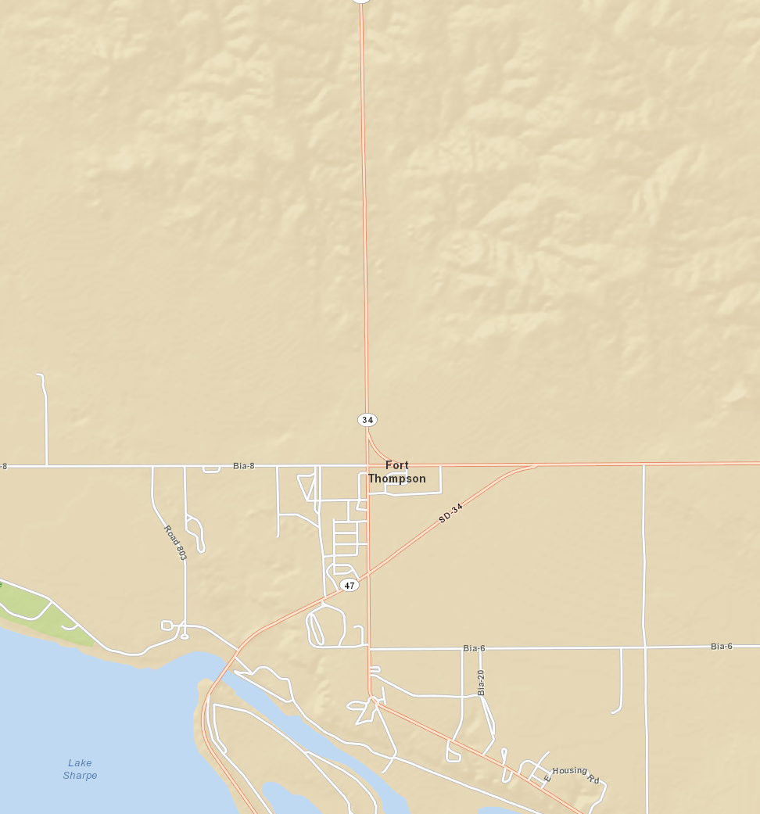



Red Bull Burn Unit

## 2. Project Map

|  |  |
| --- | --- |
| **Name of Preparer(s):** | EMB |
| **Date:** | 1/11/12 |
| **Project Name:** | Crow Creek |
| **Burn Unit Name:** | Red Bull |

**<Insert Map Here>**

# Appendix B: Technical Reviewer Checklist

|  |  |  |
| --- | --- | --- |
| Prescribed Fire Plan Elements | S/U | Comments |
| 1. Signature page | S |  |
| 1. GO/NO-GO Checklists | S |  |
| 1. Complexity Analysis Summary | S |  |
| 1. Description of the Prescribed Fire Area | S |  |
| 1. Objectives | S | see objective additions |
| 1. Funding | S |  |
| 1. Prescription | S | clarify questions in narrative |
| 1. Scheduling | S |  |
| 1. Pre-burn Considerations and Weather | S |  |
| 1. Briefing | S |  |
| 1. Organization and Equipment | S | clarify tender operation question |
| 1. Communication | S |  |
| 1. Public and Personnel Safety, Medical | S |  |
| 1. Test Fire | S | see clarification |
| 1. Ignition Plan | S |  |
| 1. Holding Plan | S | see clarification |
| 1. Contingency Plan | S |  |
| 1. Wildfire Conversion | S |  |
| 1. Smoke Management and Air Quality | S |  |
| 1. Monitoring | S |  |
| 1. Post-burn Activities | S |  |
| Appendix A: Maps | S |  |
| Appendix B. Technical Review Checklist | S | subject to changes and answering comments – plan signed by each tech reviewer |
| Appendix C: Complexity Analysis | S |  |
| Appendix D: Agency-Specific Job Hazard Analysis | S |  |
| Appendix E: Fire Prediction Modeling Runs or Empirical Documentation | S |  |
| Other | S |  |

S = Satisfactory U = Unsatisfactory

Recommended for Approval: _________ Not Recommended for Approval: _________

______________________ ___________ ________________  
 Technical Reviewer Qualification and currency (Y/N) Date

🞏 Approval is recommended subject to the completion of all requirements listed in the comments section, or in the Prescribed Fire Plan.

# Appendix C: Complexity Analysis

**Instructions:** This worksheet is designed to be used with the Prescribed Fire Complexity Rating descriptors on Page 6 of the [Prescribed Fire Complexity Rating System Guide](http://www.nwcg.gov/pms/RxFire/complexity_analysis.pdf).

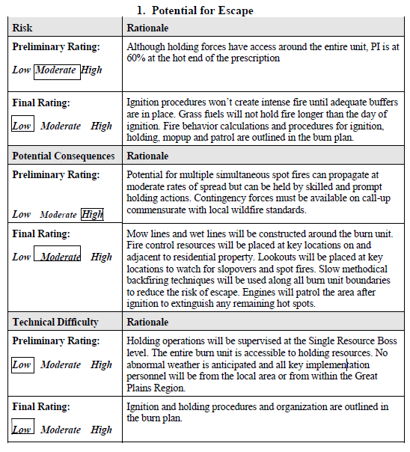

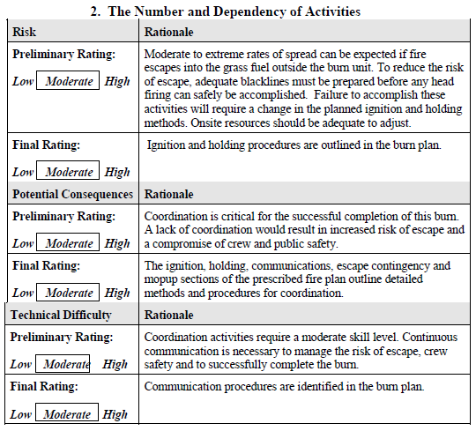

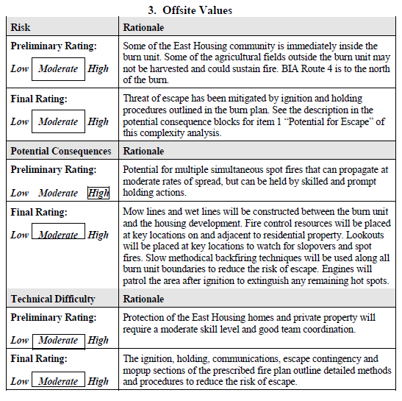

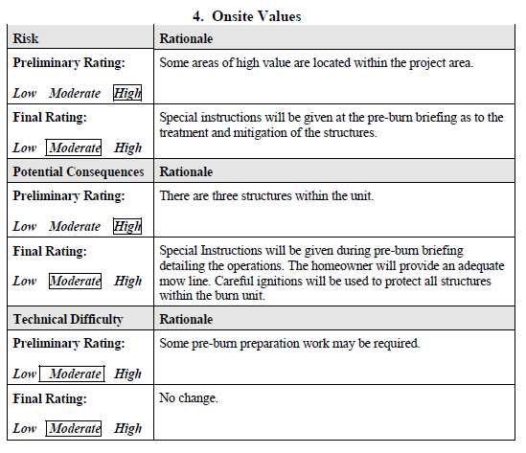

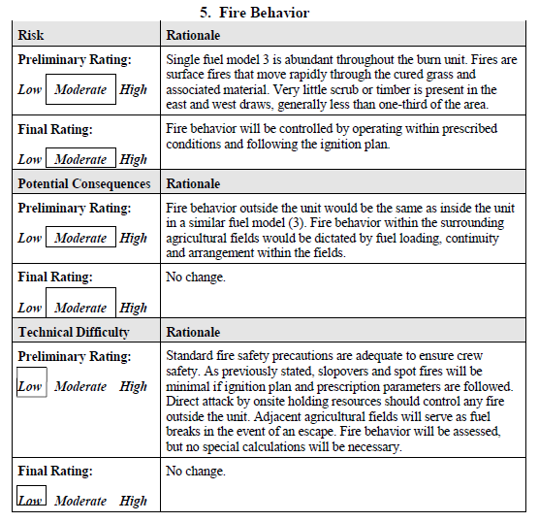

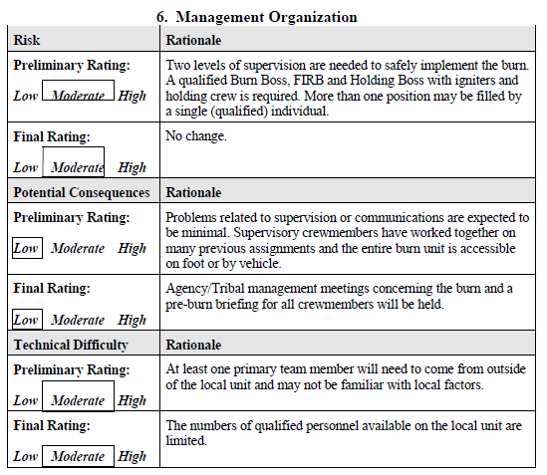

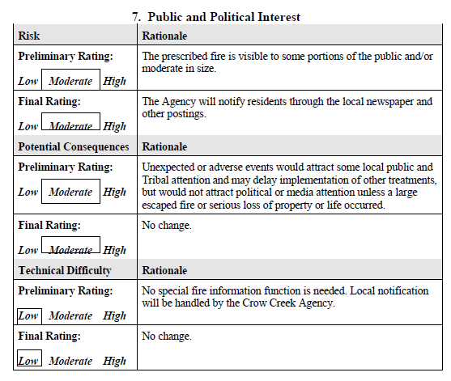

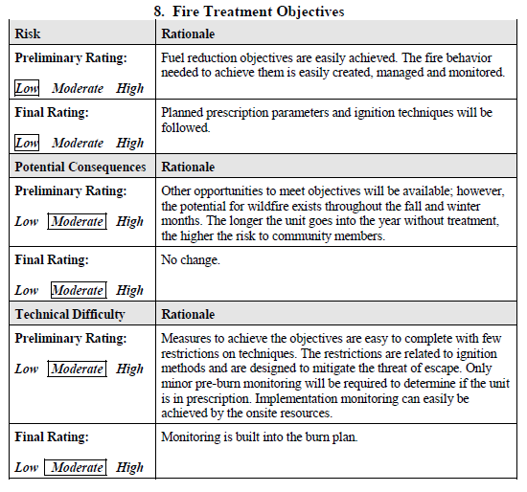

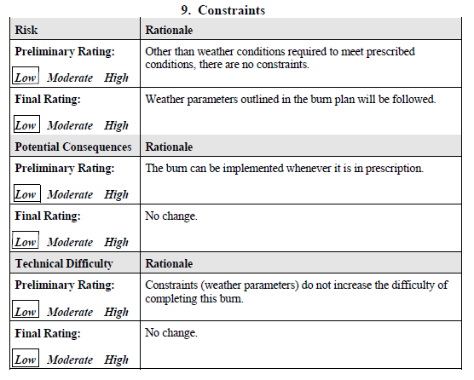

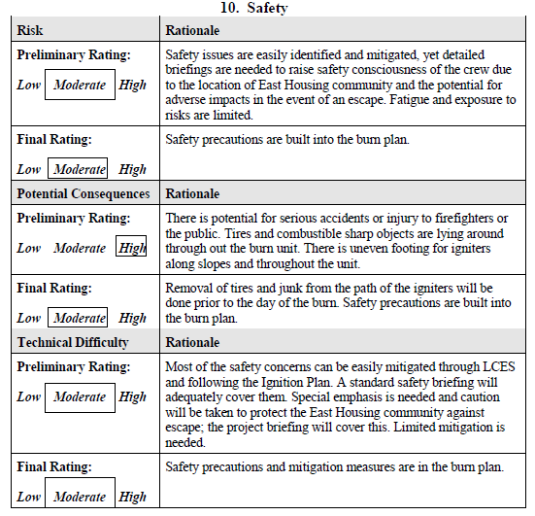

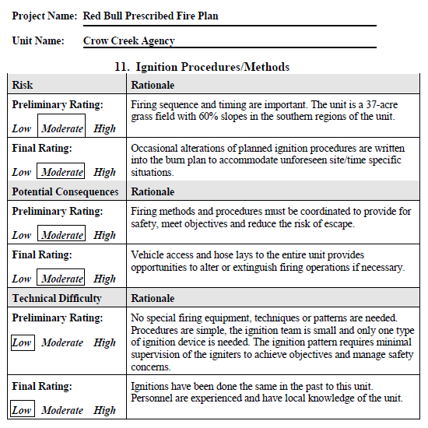

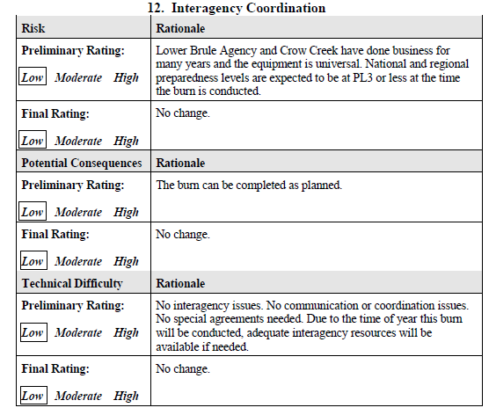

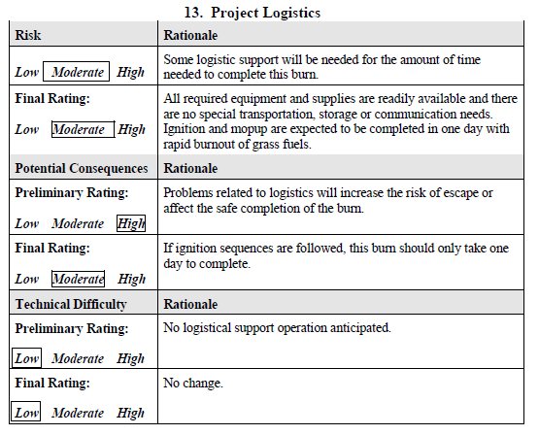

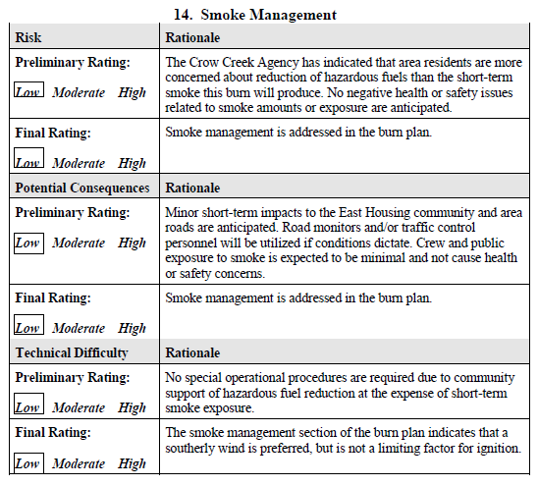

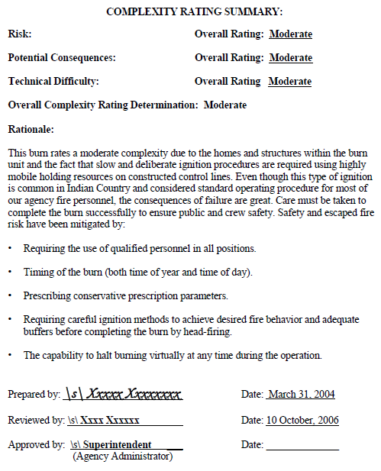

# Appendix D: Agency-Specific Job Hazard Analysis

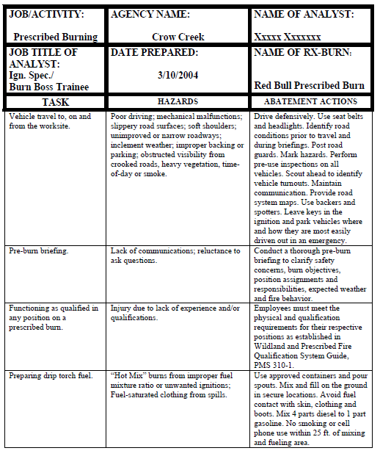

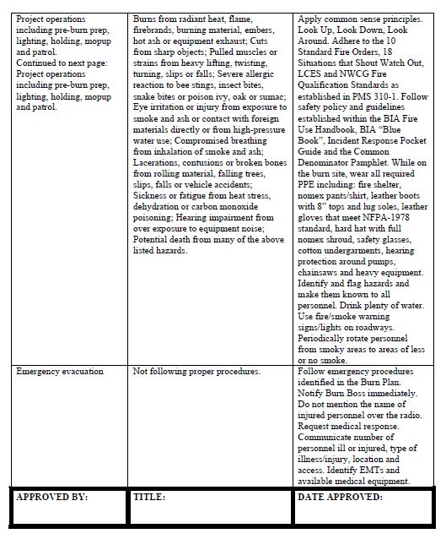

# Appendix E: Fire Behavior Modeling Documentation or Empirical Documentation

